Zee music company analysis requirements

Requirements:
- Identify the artist with the highest number of streams.
Maya Rivers 1029
- Display the top 10 artists based on total revenue.
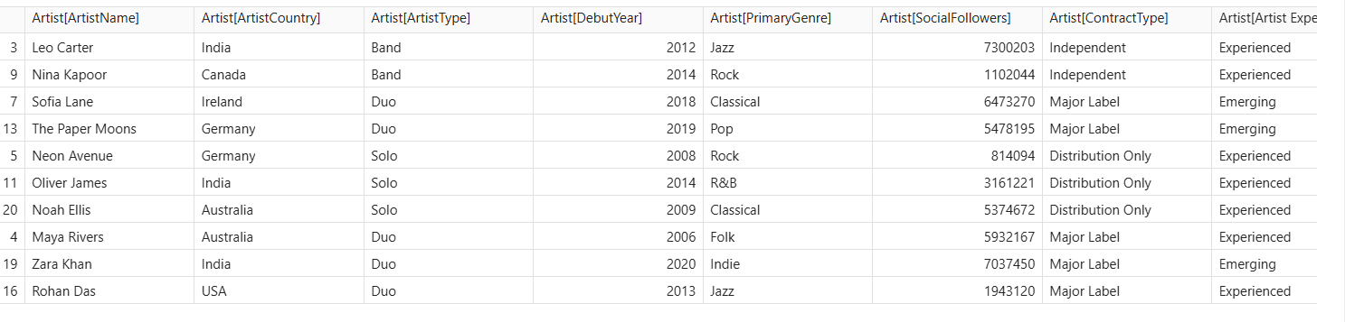
- Compare the revenue generated by different genres.
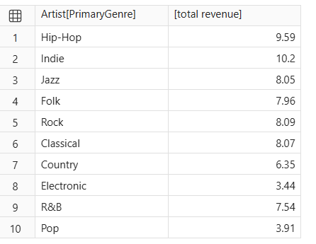
- Identify the album with the highest listening activity.
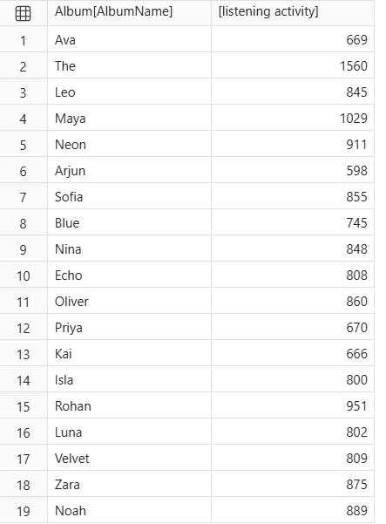
- Analyse monthly stream trends.
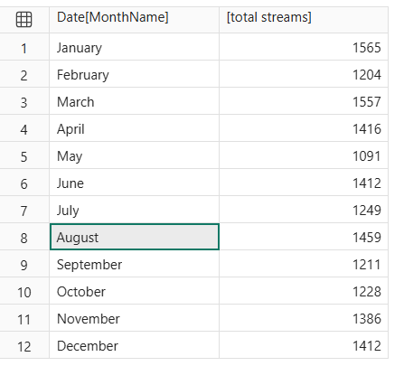
- Compare revenue between 2024 and 2025.
2024 36.610
2025 36.58

Requirements
- Determine which subscription type generates the highest total revenue.

- Compare the average revenue per record for each subscription type.
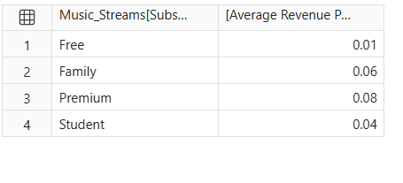
- Identify which device accounts for the most streaming activity.
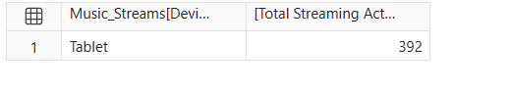
- Compare listening behaviour across countries.
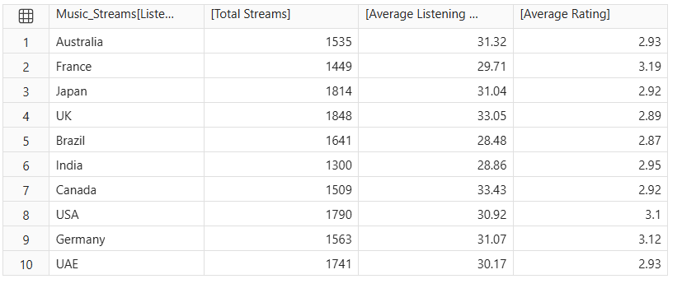
- Find which playlist source has the highest number of streams.
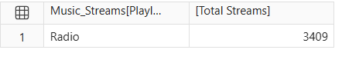
- Compare completed and not-completed records.
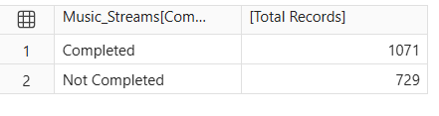
- Analyse the relationship between SkipCount and Rating.
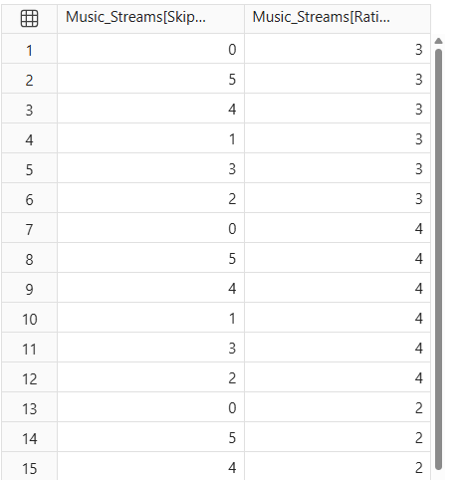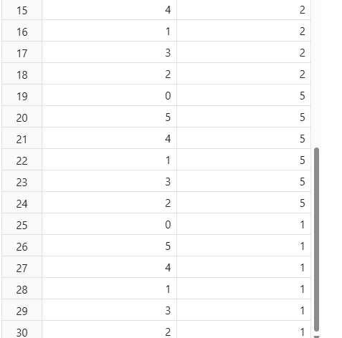

- Compare revenue growth with the previous year.
2024 36.610
2025 36.58

- Identify artists or albums with high streams but relatively low revenue.


